Network Model

🌐 What is the Network Data Model?
# Source: AI Source: Provided by: [Data Path: Persons Table -> ID Column: 1, Name_En Column: Motasem Essam] -> From: [ChatGPT] on [6/10/2026]
The Network Model is a data model where data is organized as a graph: records are nodes, and relationships are more flexible than the tree-like structure of the Hierarchical Model.
📌 In the Network Model, a record can have multiple parents, and many-to-many relationships are allowed.

🧠 Key Concept
# Source: AI Source: Provided by: [Data Path: Persons Table -> ID Column: 1, Name_En Column: Motasem Essam] -> From: [ChatGPT] on [6/10/2026]
- Records are called nodes or entities
- Relationships are called edges or sets
- Uses a graph structure instead of a strict hierarchy
📊 Example:
A student can enroll in many courses
A course can have many students
✔️ This is many-to-many — and it's easily modeled in the Network Model.

📘 Real-World Analogy
# Source: AI Source: Provided by: [Data Path: Persons Table -> ID Column: 1, Name_En Column: Motasem Essam] -> From: [ChatGPT] on [6/10/2026]
Hierarchical Model = family tree
Network Model = social network (e.g., people connected in many ways)

🧩 Structure in the Network Model
# Source: AI Source: Provided by: [Data Path: Persons Table -> ID Column: 1, Name_En Column: Motasem Essam] -> From: [ChatGPT] on [6/10/2026]
Instead of Parent → Child (like in Hierarchical), you have:
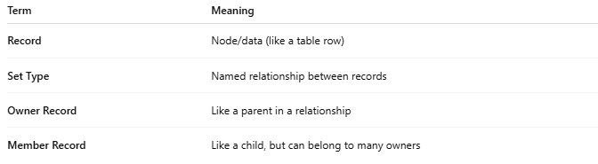
Term | Meaning
Record | Node/data (like a table row)
Set Type | Named relationship between records
Owner Record | Like a parent in a relationship
Member Record | Like a child, but can belong to many owners

🔁 Example: Students and Courses
# Source: AI Source: Provided by: [Data Path: Persons Table -> ID Column: 1, Name_En Column: Motasem Essam] -> From: [ChatGPT] on [6/10/2026]
In a Hierarchical model, you'd have:
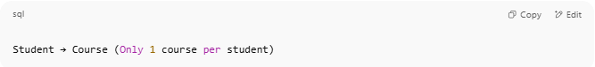
Student → Course (Only 1 course per student)

In a Network model, you can do:
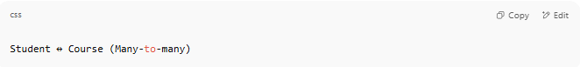
Student ↔ Course (Many-to-many)

🛠️ Diagram of Network Model
# Source: AI Source: Provided by: [Data Path: Persons Table -> ID Column: 1, Name_En Column: Motasem Essam] -> From: [ChatGPT] on [6/10/2026]
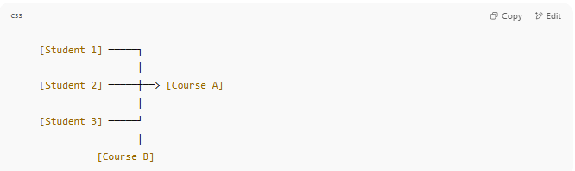
[Student 1] ─────┐
│
[Student 2] ─────┼──> [Course A]
│
[Student 3] ─────┘
│
[Course B]

✔️ Each student is connected to multiple courses, and each course is connected to multiple students

✅ Features of the Network Model
# Source: AI Source: Provided by: [Data Path: Persons Table -> ID Column: 1, Name_En Column: Motasem Essam] -> From: [ChatGPT] on [6/10/2026]
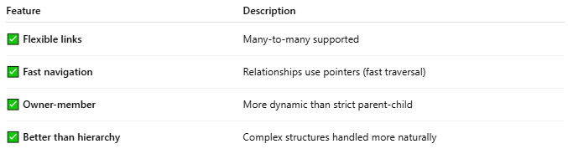
Feature | Description
✅ Flexible links | Many-to-many supported
✅ Fast navigation | Relationships use pointers (fast traversal)
✅ Owner-member | More dynamic than strict parent-child
✅ Better than hierarchy | Complex structures handled more naturally

❌ Limitations of the Network Model
# Source: AI Source: Provided by: [Data Path: Persons Table -> ID Column: 1, Name_En Column: Motasem Essam] -> From: [ChatGPT] on [6/10/2026]
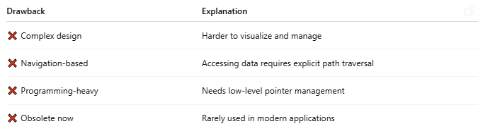
Drawback | Explanation
❌ Complex design | Harder to visualize and manage
❌ Navigation-based | Accessing data requires explicit path traversal
❌ Programming-heavy | Needs low-level pointer management
❌ Obsolete now | Rarely used in modern applications

🧰 Used In:
# Source: AI Source: Provided by: [Data Path: Persons Table -> ID Column: 1, Name_En Column: Motasem Essam] -> From: [ChatGPT] on [6/10/2026]
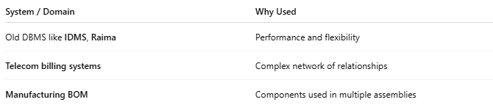
System / Domain | Why Used
Old DBMS like IDMS, Raima | Performance and flexibility
Telecom billing systems | Complex network of relationships
Manufacturing BOM | Components used in multiple assemblies

🔄 Comparison: Hierarchical vs Network
# Source: AI Source: Provided by: [Data Path: Persons Table -> ID Column: 1, Name_En Column: Motasem Essam] -> From: [ChatGPT] on [6/10/2026]
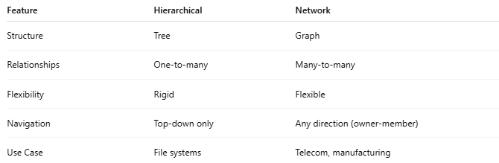
Feature | Hierarchical | Network
Structure | Tree | Graph
Relationships | One-to-many | Many-to-many
Flexibility | Rigid | Flexible
Navigation | Top-down only | Any direction (owner-member)
Use Case | File systems | Telecom, manufacturing

Awesome! Let’s do both:

🧱 🔄 Comparison of 4 Data Models
# Source: AI Source: Provided by: [Data Path: Persons Table -> ID Column: 1, Name_En Column: Motasem Essam] -> From: [ChatGPT] on [6/10/2026]
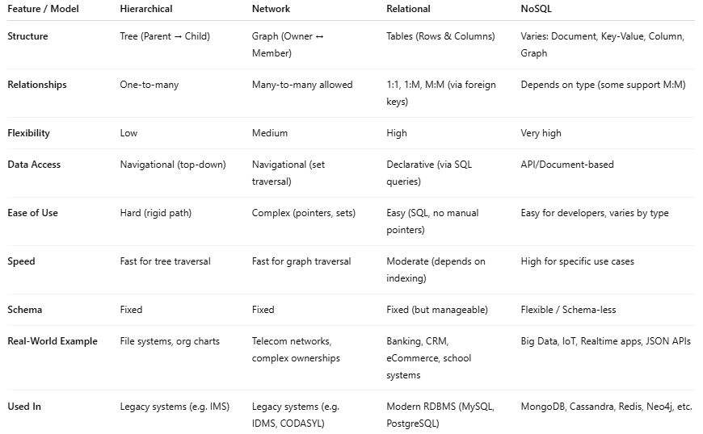
Feature / Model | Hierarchical | Network | Relational | NoSQL
Structure | Tree (Parent → Child) | Graph (Owner ↔ Member) | Tables (Rows & Columns) | Varies: Document, Key-Value, Column, Graph
Relationships | One-to-many | Many-to-many allowed | 1:1, 1:M, M:M (via foreign keys) | Depends on type (some support M:M)
Flexibility | Low | Medium | High | Very high
Data Access | Navigational (top-down) | Navigational (set traversal) | Declarative (via SQL queries) | API/Document-based
Ease of Use | Hard (rigid path) | Complex (pointers, sets) | Easy (SQL, no manual pointers) | Easy for developers, varies by type
Speed | Fast for tree traversal | Fast for graph traversal | Moderate (depends on indexing) | High for specific use cases
Schema | Fixed | Fixed | Fixed (but manageable) | Flexible / Schema-less
Real-World Example | File systems, org charts | Telecom networks, complex ownerships | Banking, CRM, eCommerce, school systems | Big Data, IoT, Realtime apps, JSON APIs
Used In | Legacy systems (e.g. IMS) | Legacy systems (e.g. IDMS, CODASYL) | Modern RDBMS (MySQL, PostgreSQL) | MongoDB, Cassandra, Redis, Neo4j, etc.

🧾 Real Example: Student–Course Relationship

Scenario:
# Source: AI Source: Provided by: [Data Path: Persons Table -> ID Column: 1, Name_En Column: Motasem Essam] -> From: [ChatGPT] on [6/10/2026]
- A student can enroll in many courses
- A course can have many students

🔢 In Network Model (graph-based):
# Source: AI Source: Provided by: [Data Path: Persons Table -> ID Column: 1, Name_En Column: Motasem Essam] -> From: [ChatGPT] on [6/10/2026]
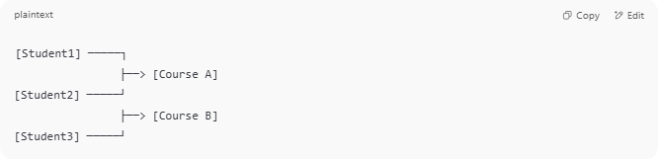
[Student1] ─────┐
├──> [Course A]
[Student2] ─────┘
├──> [Course B]
[Student3] ─────┘

You define a set for "EnrolledIn" where:
- Owner: Student
- Member: Course
- With many-to-many allowed
🔧 Access requires pointer-based navigation from student to course.

🧮 In Relational Model (SQL):
# Source: AI Source: Provided by: [Data Path: Persons Table -> ID Column: 1, Name_En Column: Motasem Essam] -> From: [ChatGPT] on [6/10/2026]
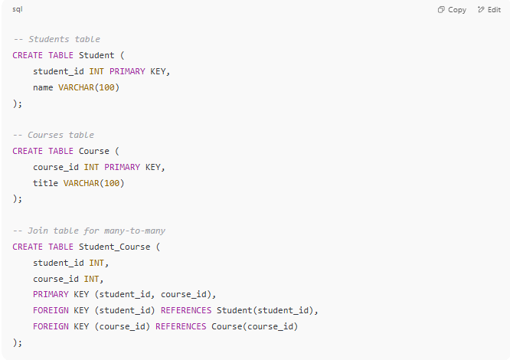
-- Students table
CREATE TABLE Student (
student_id INT PRIMARY KEY,
name VARCHAR(100)
);

-- Courses table
CREATE TABLE Course (
course_id INT PRIMARY KEY,
title VARCHAR(100)
);

-- Join table for many-to-many
CREATE TABLE Student_Course (
student_id INT,
course_id INT,
PRIMARY KEY (student_id, course_id),
FOREIGN KEY (student_id) REFERENCES Student(student_id),
FOREIGN KEY (course_id) REFERENCES Course(course_id)
);

✅ This is easier to manage and query:
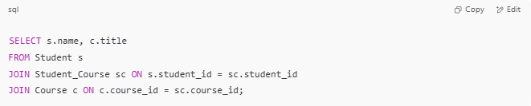
SELECT s.name, c.title
FROM Student s
JOIN Student_Course sc ON s.student_id = sc.student_id
JOIN Course c ON c.course_id = sc.course_id;

📦 In NoSQL (Document DB like MongoDB)
# Source: AI Source: Provided by: [Data Path: Persons Table -> ID Column: 1, Name_En Column: Motasem Essam] -> From: [ChatGPT] on [6/10/2026]
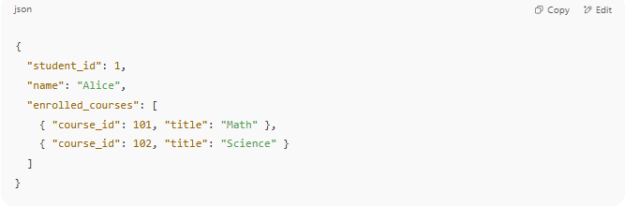
{
"student_id": 1,
"name": "Alice",
"enrolled_courses": [
{ "course_id": 101, "title": "Math" },
{ "course_id": 102, "title": "Science" }
]
}

🔧 Nested structure; good for fast access, but harder for joins or many-to-many from the course side.

🗺️ Visual Map: When to Use Each Model
# Source: AI Source: Provided by: [Data Path: Persons Table -> ID Column: 1, Name_En Column: Motasem Essam] -> From: [ChatGPT] on [6/10/2026]
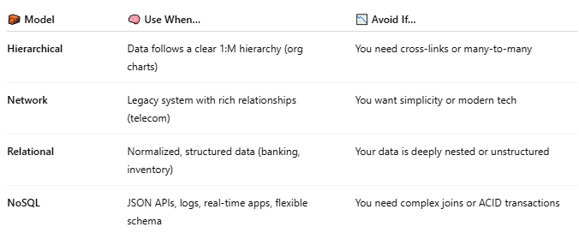

🧱 Model | 🧠 Use When… | 📉 Avoid If…
Hierarchical | Data follows a clear 1:M hierarchy (org charts) | You need cross-links or many-to-many
Network | Legacy system with rich relationships (telecom) | You want simplicity or modern tech
Relational | Normalized, structured data (banking, inventory) | Your data is deeply nested or unstructured
NoSQL | JSON APIs, logs, real-time apps, flexible schema | You need complex joins or ACID transactions

✅ Summary
# Source: AI Source: Provided by: [Data Path: Persons Table -> ID Column: 1, Name_En Column: Motasem Essam] -> From: [ChatGPT] on [6/10/2026]
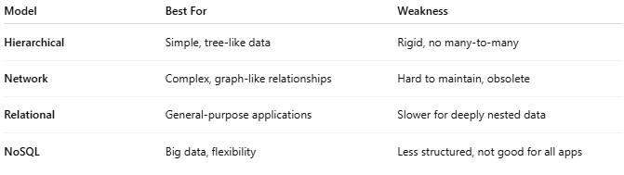
Model | Best For | Weakness
Hierarchical | Simple, tree-like data | Rigid, no many-to-many
Network | Complex, graph-like relationships | Hard to maintain, obsolete
Relational | General-purpose applications | Slower for deeply nested data
NoSQL | Big data, flexibility | Less structured, not good for all apps

🧠 Summary
# Source: AI Source: Provided by: [Data Path: Persons Table -> ID Column: 1, Name_En Column: Motasem Essam] -> From: [ChatGPT] on [6/10/2026]
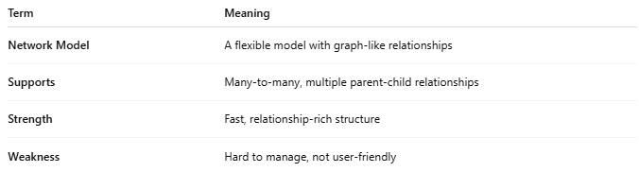
Term | Meaning
Network Model | A flexible model with graph-like relationships
Supports | Many-to-many, multiple parent-child relationships
Strength | Fast, relationship-rich structure
Weakness | Hard to manage, not user-friendly

